DEWAGEDARA D.M.E.S.
E/21/087

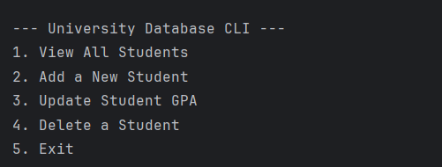

- VIEW ALL STUDENTS
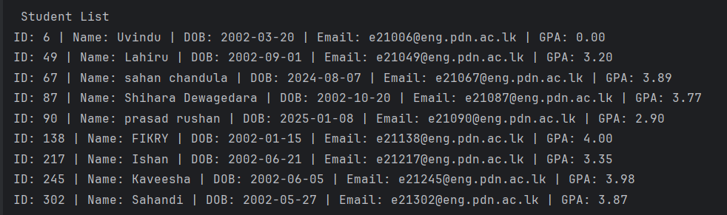

- Add new student

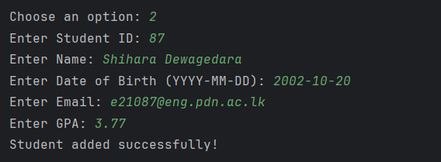

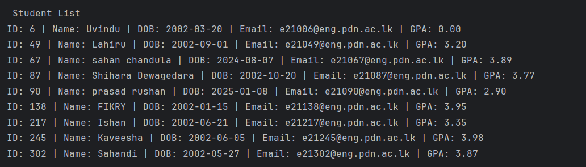

- Update student GPA

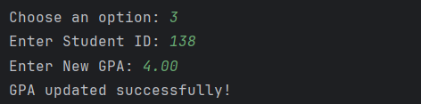

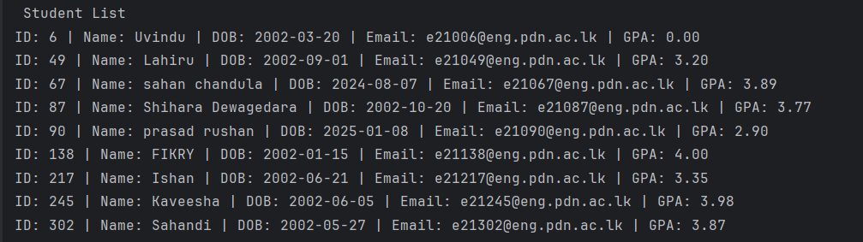

- Delete student
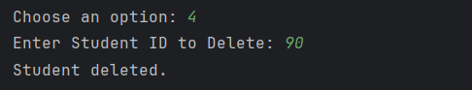

- Exit the programme
